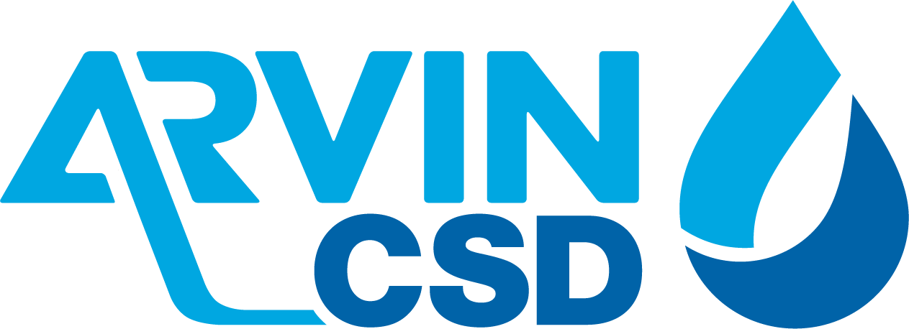

309 Campus Drive, Arvin, CA 93203
(*) REGULAR MEETING AGENDA OF THE
ARVIN COMMUNITY SERVICES DISTRICT BOARD OF DIRECTORS
Monday, December 21, 2020 6:00 P.M.
**************************************************************
Zoom Meeting Online:
https://us02web.zoom.us/j/9808042989?pwd=bFRha25tL0NlY3lFb1dDbUo3dUtrQT09
Meeting ID: 980 804 2989
Passcode: 9Ap9yf
************************************************* ******
Zoom Meeting by Phone:
One tap mobile:
+1 (669) 900-6833
Dial by your location
+1 (669) 900-6833
Meeting ID: 980 804 2989
Passcode: 134912
*******************************************************
Call Meeting to Order Board President Gallardo

Roll Call: Rafael Gallardo President
Maria Alvarez Vice President
Cynthia Moran Board Director
Aurelio Reyna Board Director
Maria Moreno Pantoja Board Director
Staff
Raul Barraza, Jr. General Manager
Alan Peake District Counsel
Dee Jaspar District Engineer
************************************************************************************
This meeting is held in accordance with the Brown Act. Individuals may address the Board on any matter listed on this agenda, excluding closed session. Members of the public desiring to address the Board must request recognition from the Board President. Presentation by members of the public is limited to two minutes each per agenda item.

Flag Salute: Board and audience salute flag.

- Public Comment:
This portion of the meeting is set aside for members of the public to address any matter not on this agenda and over which the Board has jurisdiction. Comments are limited to 2 minutes for each person and 15 minutes on each subject.

- Consent Calendar
The Consent Calendar consists of items that in staff’s opinion are routine and non-controversial. These items are approved in one motion unless a Board Member or member of the public removes a particular item.
  - Approval of Regular Meeting Minutes for December 7, 2020
  - Accounts Payable for December 2020
Motion: ______________________________________________________________
Director _______________________, seconded Director_______________________
Roll Call: BD Pantoja-Moreno__ BD Reyna __ BD Moran__ VP Alvarez__ BP Gallardo__

- Board to discuss and take action re: Electing New Board President
Motion: ______________________________________________________________
Director _______________________, seconded Director_______________________
Roll Call: BD Pantoja-Moreno__ BD Reyna __ BD Moran__ VP Alvarez__ BP Gallardo__

- Board to discuss and take action re: Electing New Board Vice President
Motion: ______________________________________________________________
Director _______________________, seconded Director_______________________
Roll Call: BD Pantoja-Moreno__ BD Reyna __ BD Moran__ VP Alvarez__ BP Gallardo__

- Monthly Operations Review for the month of November 2020

- Project Updates:
  - Arsenic Mitigation Plan Phase II
    - Well No. 18
  - EPA Replacement Well No. 12

- Comments:
  - General Manager
  - Legal Counsel
  - District Engineer

- Board Member Comments:
This portion of the meeting is set aside to provide the Board with an opportunity to bring any new matters to the attention of the District. However, while no action can be taken on any matter discussed during this portion of the meeting, a Board Member may request that a subject be placed on an upcoming agenda. This portion of the meeting also allows the Board to get a brief update on any matter addressed at a previous meeting.

  - Director Reyna
  - Director Moran
  - Director Pantoja-Moreno
  - Vice President Alvarez
  - President Gallardo

- Closed Session
Motion to go into closed session made by ____________, seconded by ______________.
Roll Call: BD Rodriguez ___ BD Reyna __ BD Moran __ VP Alvarez __ BP Gallardo __

  - Conference with Labor Negotiators General Manger and Legal Counsel: Laborers International Union of North America 777 Gov’t code 54957.6

Motion to go back into open session made by ___________, seconded by ____________.
Roll Call: BD Rodriguez ___ BD Reyna __ BD Moran __ VP Alvarez __ BP Gallardo __

- Adjournment:

Director ________________________, seconded Director___________________________
Roll Call: BD Pantoja-Moreno__ BD Reyna __ BD Moran__ VP Alvarez__ BP Gallardo__

I hereby certify under perjury under the laws of the State of California that the foregoing agenda was posted on the Arvin Community Services office window and website not less than 72 hours prior to the meeting dated December 21, 2020.

___________________________
Raul Barraza, Jr.
Board Secretary/General Manager

(*) Some or all board members might attend electronically.
_____________________________________________________________________________
AMERICANS with DISABILITIES ACT: In compliance with the ADA, if you need special assistance to participate in a District meeting or other services offered by the District, please contact the District Board Secretary's office (661) 854-2127. Notification of at least 24 hours prior to the meeting or time when services are needed will assist the District staff in assuring that reasonable arrangements can be made to provide accessibility to the meeting or services.

