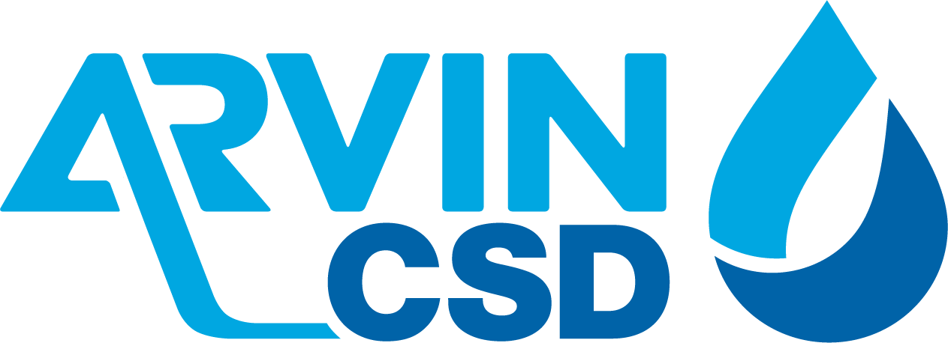

309 Campus Drive, Arvin, CA 93203
(*) REGULAR MEETING AGENDA OF THE REGULAR MEETING OF
ARVIN COMMUNITY SERVICES DISTRICT BOARD OF DIRECTORS
Office Closed for President’s Day February 21, 2022
Tuesday, February 22, 2021 6:00 P.M.
**************************************************************
Zoom Meeting Online:
https://us02web.zoom.us/j/9808042989?pwd=bFRha25tL0NlY3lFb1dDbUo3dUtrQT09
Meeting ID: 980 804 2989
Passcode: 9Ap9yf
*******************************************************
Zoom Meeting by Phone
One tap mobile:
+1 (669) 900-6833
Dial by your location
+1 (669) 900-6833
Meeting ID: 980 804 2989
Passcode: 134912
*******************************************************
Call Meeting to Order Board President Alvarez

Roll Call: Maria Alvarez President
Aurelio Reyna Vice President
Rafael Gallardo Board Director
Cynthia Moran Board Director
Maria Pantoja Board Director
Staff
Raul Barraza, Jr. General Manager
Alan Peake District Counsel
Dee Jaspar District Engineer
************************************************************************************
This meeting is held in accordance with the Brown Act. Individuals may address the Board on any matter listed on this agenda, excluding closed session. Members of the public desiring to address the Board must request recognition from the Board President. Presentation by members of the public is limited to two minutes each per agenda item.

Flag Salute: Board and audience salute flag.

- Public Comment
This portion of the meeting is set aside for members of the public to address any matter not on this agenda and over which the Board has jurisdiction. Comments are limited to 2 minutes for each person and 15 minutes on each subject.

- Consent Calendar
The Consent Calendar consists of items that in staff’s opinion are routine and non-controversial. These items are approved in one motion unless a Board Member or member of the public removes a particular item.
  - Approval of Regular Meeting Minutes of February 7, 2021
  - Accounts Payable for February 7, 2022 – February 18, 2022
Motion: ______________________________________________________________
Director _______________________, seconded Director_______________________
Roll Call: BD Gallardo __ BD Moran __ BD Pantoja __ VP Reyna __ BP Alvarez __

- Board to discuss and take possible action re: Reapproval of Resolution 05-2021 to continue to have board meetings held by teleconference due to ongoing State of Emergency related to COVID-19
Motion: __________________________________________________________________
Director______________________, seconded Director_____________________________
Roll Call: BD Gallardo __ BD Moran __ BD Pantoja __ VP Reyna __ BP Alvarez __

- Board to discuss and take possible action re: Approval of contracting with TeleDirect Communications Inc. for District Call Services
Motion: __________________________________________________________________
Director______________________, seconded Director_____________________________
Roll Call: BD Gallardo __ BD Moran __ BD Pantoja __ VP Reyna __ BP Alvarez __

- Board to discuss and take possible action re: Approval of membership renewal with California Special Districts Association
Motion: __________________________________________________________________
Director______________________, seconded Director_____________________________
Roll Call: BD Gallardo __ BD Moran __ BD Pantoja __ VP Reyna __ BP Alvarez __

- Update re: Districts protocols and procedures regarding COVID-19

- Staff Comments:
  - General Manager Report
  - Legal Counsel
  - District Engineer

- Board Member Comments:
This portion of the meeting is set aside to provide the Board with an opportunity to bring any new matters to the attention of the District. However, while no action can be taken on any matter discussed during this portion of the meeting, a Board Member may request that a subject be placed on an upcoming agenda. This portion of the meeting also allows the Board to get a brief update on any matter addressed at a previous meeting.

  - Director Gallardo
  - Director Moran
  - Director Pantoja
  - Vice President Reyna
  - President Alvarez

- Adjournment:
Director ________________________, seconded Director___________________________
Roll Call: BD Gallardo __ BD Moran __ BD Pantoja __ VP Reyna __ BP Alvarez __

I hereby certify under perjury under the laws of the State of California that the foregoing agenda was posted on the Arvin Community Services office window and website not less than 72 hours prior to the meeting dated February 22, 2022.

Raul Barraza, Jr.
Board Secretary/General Manager

AMERICANS with DISABILITIES ACT: In compliance with the ADA, if you need special assistance to participate in a District meeting or other services offered by the District, please contact the District Board Secretary's office (661) 854-2127. Notification of at least 24 hours prior to the meeting or time when services are needed will assist the District staff in assuring that reasonable arrangements can be made to provide accessibility to the meeting or services.
(*) Some or all board members might attend electronically.

